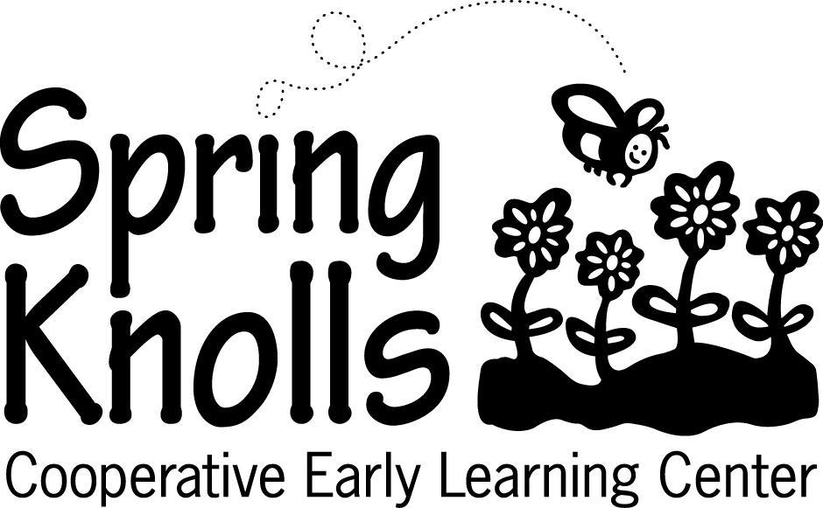
8900 GEORGIA AVENUE, SILVER SPRING, MARYLAND • (301) 650-0086 • springknolls4@gmail.com

New Student Application for Program Year 2024-25

Instructions
Please fill out one application per child. A nonrefundable fee of $65 should accompany each application. Completed applications and checks should be mailed to the address above or emailed to springknolls4@gmail.com. Checks should be made out to Spring Knolls Cooperative Early Learning Center. Electronic payments may also be made via PayPal.

CHILD’S INFORMATION
Name:
Address: Street: Apartment:
City: State: Zip:
Home Phone:
Date of Birth (MM/DD/Year): ☐ Male ☐ Female Race/ethnicity of child*
*This item is optional; however, Spring Knolls has a commitment to maintaining a diverse student population and information about your child’s race/ethnicity helps us achieve that goal.

PARENT’S INFORMATION
Parent’s Name: | Parent’s Name:
Relationship to the child: | Relationship to the child:
Home Address (if different from the applicant) | Home Address: (if different from the applicant)
Phone (H): | Phone (H):
Phone (M): | Phone (M):
Email: | Email:
Work Information  Occupation:  Address:  Phone: | Work Information  Occupation:  Address:  Phone:

CLASS INFORMATION
Check the morning program in which you have an interest. These classes are offered from 9am to 12pm.

CLASS | STUDENT’S REQUIRED AGE | CLASS DAYS
☐ 2-day Twos class | 2 by 9/1/24 | Thursday & Friday
☐ 3-day Twos class | 2 by 9/1/24 | Monday, Tuesday & Wednesday
☐ 5-day Twos class | 2 by 9/1/24 | Monday through Friday
☐ 3-day Threes class | 3 by 9/1/24 | Monday, Tuesday & Wednesday
☐ 5-day Threes class | 3 by 9/1/24 | Monday through Friday
☐ 5-day Pre-K class | 4 by 9/1/24 | Monday through Friday

SCHEDULE

Check the box next to your choice(s) of schedule. These options are available for all children enrolled in any of our morning programs.

 | Monday | Tuesday | Wednesday | Thursday | Friday
☐ Early Drop-off (8:30-9:00 am)
☐ Half Day (9:00 am – 12:00 pm)
☐ Lunch Bunch (12:00 pm – 1:30 pm)
☐ Enrichment (12:00 pm – 3:00 pm)
☐ Extended Day (3:00 pm – 5:30 pm)

Note: All students have the option to “drop in” for Enrichment and Extended Day classes on a periodic basis for a per-day fee, space permitting.

Please indicate membership option:
☐ My family would be interested in cooping
☐ My family would not be interested in cooping

ADDITIONAL INFORMATION
Have you applied to Spring Knolls before? ☐ Yes ☐ No If so, when?

How did you learn about Spring Knolls? Please be as specific as possible.

What are you hoping to find in a preschool? Please be as specific as possible.

It is important for us to know of any special needs your child might have. Please note any allergies or special conditions such as physical, emotional, or developmental needs. Additionally, please list any therapies or evaluations your child has received or is currently receiving.

Please provide any additional information you may wish to share about your child in the space below.

COMMITTEES / FAMILY RESPONSIBILITIES
Spring Knolls is a non-profit, parent-led cooperative nursery school. Each family at the school is required to serve on a parent committee, act as a Board officer, or support a specific administrative role. One or two committee chairpersons, who may also serve on the Board of Directors, lead the committees. We are constantly in need of families with all types of backgrounds that can help us run the school. Identify below the talents, skills, or professional experience that your family can offer.
Check areas of interest/experience
☐ Accounting/Bookkeeping/Financial Planning | ☐ Leadership (Non-profit or other)
☐ Administrative Support/Office Management | ☐ Legal Expertise
☐ Creative Arts | ☐ Event Planning
☐ Database Management | ☐ Information Technology (hardware, software)
☐ Fundraising | ☐ Non-profit Board Experience
☐ General Contracting/Facilities Management | ☐ Marketing/Communications
☐ Human Resources | ☐ Website Design/Development
☐ Education/School Administration | ☐ Other (Please explain.)

Explain the ways you see yourself contributing to the Spring Knolls community:

SIGNATURE
The information as submitted on this form and on any attachment is accurate, complete, and true to the best of my knowledge.

Signature ________________________________________ Date ___________________

Print Name _______________________________________ Relationship to child _____________________

SCHOLARSHIP FUND
If you would like more information on the scholarship fund, please contact our interim director, Joan Morales, by phone at 301-650-0086 or by email at springknolls4@gmail.com.

Spring Knolls Cooperative Early Learning Center does not discriminate on the basis of race, color, national or ethnic origin in administration of its educational policies, admissions policies, scholarships, and other school-administered programs.

